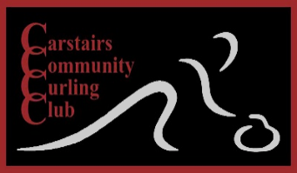
Carstairs Open Sturling
Progressive Cash Draw Bonspiel

Thursday, December 30, 2021
Entry fee $50. Per team
This Photo by Unknown Author is licensed under CC BY
Every team plays three Games
with cash payouts for all wins.
Limit 16 Teams
Start time 9:00 AM
To enter please contact Dennis McConnell at:
Phone: 403 337 2586
Text: 403 861 5895
Email: conimero@shaw.ca

All participants must be fully vaccinated.

